**INSY 5373: Project Management**

**SCRUM: Roles and Responsibilities**

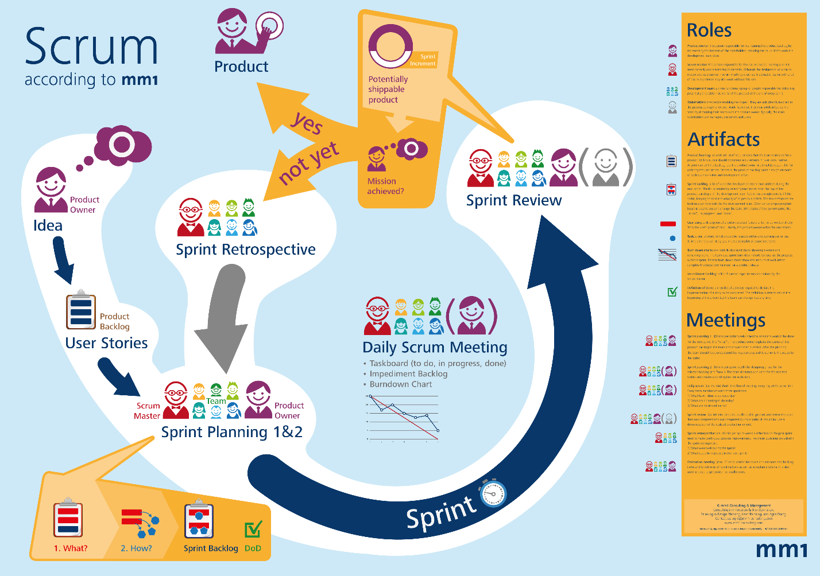

Agrawal, Shruti

Dhawle, Nikita

Sivakumar, Sujatha

Sivaselvan, Arjun Ragavendran

Soundrapandian, Siddharth Pandian

Tariq, Hamad

**Table of Contents**

Contents

Introduction 3

Scrum Master 3

The Scrum Team Role 4

Product Owner: 5

Stakeholder: 6

Conclusion: 6

References: 6

**Introduction:**

Scrum is a methodology for managing software delivery that comes under the broader umbrella of agile project management. It provides a framework for incremental practices that help in organizations in delivering working software more frequently.

In order to understand Scrum in a better way we first have to take a brief introduction of Agile. Agile methodology is an alternative to traditional project management that is typically used in software development. It helps teams to respond to unpredictability through fixed length incremental, iterative work rhythm which are known as sprints.

There are various agile methodologies; all of them use almost the same philosophy, as well as the same characteristics and practices. But from implementation point, each has its own recipe of practice, terminology and tactics. Below are a few examples of methodologies that come under Agile:

Scrum, Kanban, XP, Crystal, Lean etc.

After having a brief overview of Agile let us come back to our topic of consideration i.e. Scrum.

Scrum is an agile project management methodology or framework used primarily to develop software projects with the goal of delivering new software capability every 2 to 4 weeks. This approach has made it easier to develop high quality software faster.

In order to make it more clear let us understand the relationship between Scrum and Agile project management. First of all Scrum is a sub group of Agile. Agile consists of a set of values and principles that describes a group’s day to day interactions and activities. It is important to know that Agile itself is not prescriptive or specific. The Scrum methodology follows these values and principles of Agile, but includes further definitions and specifications, especially regarding certain software development practices.

Now we shall see the different roles in a SCRUM project and their responsibilities

1. **Scrum Master**
2. **Scrum Team**
3. **Product Owner**
4. **Stakeholders**

**Scrum Master**

The Scrum Master is a person who acts as the backbone of Agile Methodology. Generally a scrum master is considered as a term for Project manager in agile development, however this is not true in convention.  A scrum master is not related to a project delivery. He is a facilitator, champion, coach and a cheerleader for the team who guides the development process and enables the organization to accept the new roles brought about by the scrum framework. An organization has to change its philosophy to adopt agile methodology. The Scrum framework prohibits a person from playing multiple roles and tends to place distinct responsibilities on the team. Hence, a scrum master is bestowed with sole authority in order to ensure that the process proceeds as intended.

**Responsibilities**

Meetings

* Preparing for team meetings and facilitation of post processing activities.
* Conducting special retrospective meetings.

Team Management

* Coaching the team.
* Liaise conflicts within the team and guide them in taking appropriate decisions.
* Stimulate self- organization of development team and help them achieve a common goal.
* Share insights with the team and the organization through blogs, conferences etc.
* Serve as the point of contact for the team members and stakeholders regarding agile.
* Help the team to overcome obstacles.
* Reflect scrum values to team and make them stick to their structure framework.
* Ask open questions to the team and check the models being used by them.

Learning

* Stay tuned with new advancements in agile methodology.
* Formulate information radiators (bulletin boards) for the team.
* Giving feedback to the team
* Invigorate the use of agile techniques for development (this is the most important responsibility of a scrum master).
* Challenging the team for new innovations.
* Constant information exchange with scrum masters in other organizations.

Product

* Guidance to formulate product vision
* Guidance for reordering product backlogs
* Help the management to foster release plans.

Miscellaneous

* Enhance the focus of the team by acting as a buffer between the team and distractions.
* Guide the team to maintain the scrum tools such as story board, action board, charts, backlogs etc., perfectly.

**The Scrum Team Role:**

Scrum teams are known as the champions for most of the development practices followed in Agile Methodology. The team is ultimately responsible for completing the goal of sprint and committing to deliver the goal within the given timeframe specified in the sprint. Scrum team usually contains of 5-7 members and this number may vary depending on the size of the project. The team members have different skill sets and cross trainings are done so that everyone is on the same page. The scrum team usually works with the Product Manager and decides on which all items to pick up for the current sprint and also check on what items from the Product backlog can be delivered with the current sprint. In a scrum environment the project specifically does not include any of the traditional software engineering roles such as programmer, designer, business Analyst, tester or architect. Everyone on the project should strive together to complete the set of items that have been committed to complete within a sprint. Because of this, Scrum teams develop a deep form of comradeship and a feeling that "we're all in this together."

Responsibilities of the Scrum Team:

* Same norms and rules should be followed by the Scrum team.
* Be in touch with the Product Owner to analyze and divide the product backlog.
* Be Enthusiastic and helpful to maintain Sprint backlog and Sprint Burn down chart.
* Perform presentations to client on completion of items from a Sprint.
* Be keen to implement action items specified in Retrospective sessions performed at the end of each sprint
* Take up the tasks of Sprint Planning, Daily Scrum meeting and Retrospective sessions if the Scrum master is not present for any reason.
* Make sure to attend all the scrum meetings.
* Team should always be ready and eager to help other team members.
* Participate and share knowledge and experience among the Team, Product Owner, Scrum Master and Stakeholders.

**Product Owner:**

A Project’s key stakeholder is the product owner. A part of the product owner’s responsibility is to envision what is to be built and convey the same to the scrum team. This is essential to start any agile software development. The product owner does this through the product backlog, which is a hierarchical feature list for the project.

A Product owner is

* the lead user of the system
* is from marketing, product management
* One with a solid understanding of users, the market place, the competition and future trends for the domain.

This varies drastically depending on whether the team is developing a software, hardware or some other type of product. In spite of the fact that the agile PO prioritizes the product backlog on the sprint meeting, the number of sprints and the amount of work that can be done is selected by the team. It is the Product owner’s job to motivate the team with a clear and elevating goal. Every member would know what they are capable of and hence are allowed to choose which user stories from the product backlog they would deliver in every sprint.

The scrum team is committed to complete the stories from the top to the product backlog and in return the PO gives a commitment not to throw any new requirements during the sprint. Change is encouraged and only outside the sprint. Once the team starts on a sprint there is seamless focus on the goal.

A product owner role requires the following skills and traits

* Availability
* business savvy
* Communication skills.

The availability of the product owner is a key trait. An ideal product owner shows commitment by doing everything that is required to build the product in the best way which means to be engaged in the team actively. Business savvy means to understand the current trends in the market, the requirements of the client and to have a sound knowledge of the business in order to take accurate decisions. Finally communication skills are a key in any domain and so is the same for a PO. The PO will often have to interact with various stakeholders throughout the organization and beyond. Hence it is necessary to have strong communication skills in-order to convey different messages about the project to different people at any point of time.

**Stakeholder:**

Stakeholder is one of the most important role involved in SCRUM. A Stakeholder in a SCRUM process is the one that has a stake in the project. It is usually people who provide funding for the project and direct managers of the team. Sometimes it could also be project managers.

A special stakeholder often controls the budget of the project and is also called the Business Owners. Stakeholders are responsible for communicating their needs and also feedback on the product.

Following are the responsibilities of a stakeholder:

* A stakeholder usually works with a product owner and maintains a product backlog.
* He also provides feedback and expertise on the sprint planning meeting.
* A stakeholder also assists in removing the barriers, impediments for the team, product owner and a SCRUM master.
* He also avoids distracting the team during a Sprint.
* He supports the SCRUM framework.

**Conclusion:**

As we come to the end of the research paper, we will summarize the key points of the topic to reinforce the crux of the knowledge gained in this educational endeavor.

SCRUM is considered to be one of the most successful and efficient frameworks for implementing agile. With scrum, the product is created in a series of **fixed-length modules** called sprints that give the people working on the project a framework for shipping software on a regular pace.

The Product Owner holds responsibility for envisioning the product and then taking charge of the procuring and prioritization of the requirements, while having a reign over the budget and the Rate of Investment.

The Scrum Master acts as the buffer between the team and the product owner. He provides solutions for any problems faced during the production, and dons the hat of a mentor as well as an enforcer, ensuring that he coaches the team as well as ensure that the rules of Scrum are adhered to. The Scrum team is a self-organized unit, who are responsible for the creation of the product without compromising the quality. They are guided by the Scrum Master and use the framework structured by the sprints for the completion of the product.

A Stakeholder is the person who provides funding for the project and hence have a stake in it.

A project which is handled by the SCRUM methodology is usually a software platform with continuous updates over a period. The alliance of all the above roles and their effective contributions make the Scrum project a complete package.

Hence these are key elements to the understanding how SCRUM methodology works

**References:**

<http://www.pmdocuments.com/2012/09/15/agile-scrum-roles-and-responsibilities/>

<https://www.scrumalliance.org/community/articles/2009/december/scrum-in-a-nutshell>

https://www.mountaingoatsoftware.com/agile/scrum/product-owner